**Final Week 5 Submission**

**Coursera Applied Data Science: Week 4 Submission**

Planning to relocate to the city of Toronto, Canada I am looking for a neighborhood that offers a variety of amenities. There needs to be a balance of proximity to downtown Toronto, but a balanced proximity to neighborhoods in low crime areas that offer gym, coffee shops and restaurants, and other points of interest. A tool will be developed to gather appropriate neighborhood data for the Toronto area and cluster options with resulting prioritized recommendations.

A Foursquare generated dataset will be created to create a dataframe that includes venue type, relative popularity rating, and relevance to cluster location to aid in selecting the final neighborhood for relocation.

Dataset source to be initially used in conjunction with Foursquare data:

[https://en.wikipedia.org/wiki/List_of_postal_codes_of_Canada:_M,](https://en.wikipedia.org/wiki/List_of_postal_codes_of_Canada:_M)

**Coursera Applied Data Science: Week 5 Submission**

The associated Jupyter Notebook created for this project can be found on GitHub here:

The Toronto, Canada region will be the relocation point for a new job in the down-town area for an IT firm. The study as outlined in Week 4 will search the various neighborhoods surrounding the city of Toronto for specific amenities that are desirable to have in a new locale.

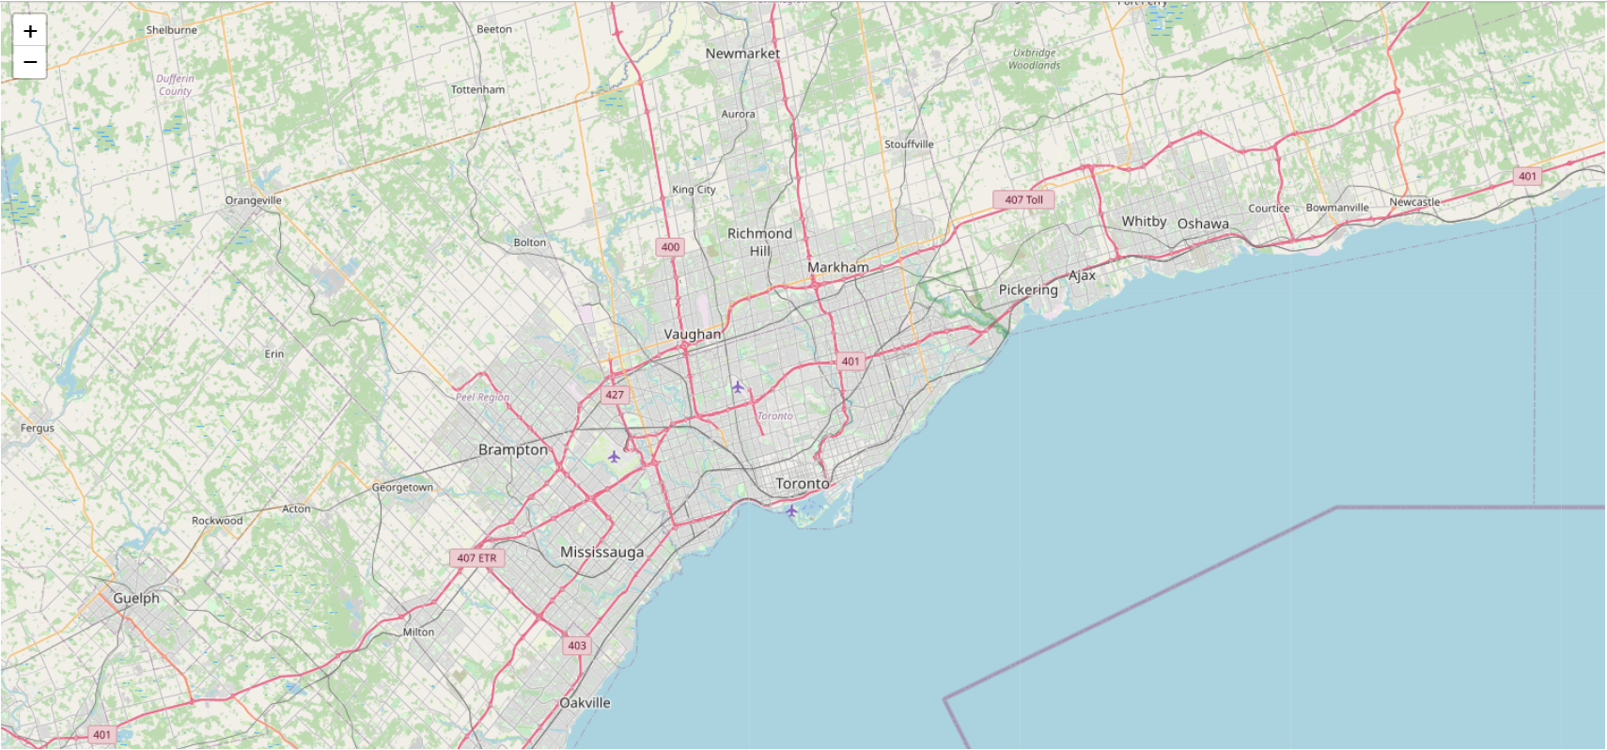

Neighborhood data was gathered from the internet based on postal code & borough and plotted on the map of Toronto to indicate relative location of areas under consideration.

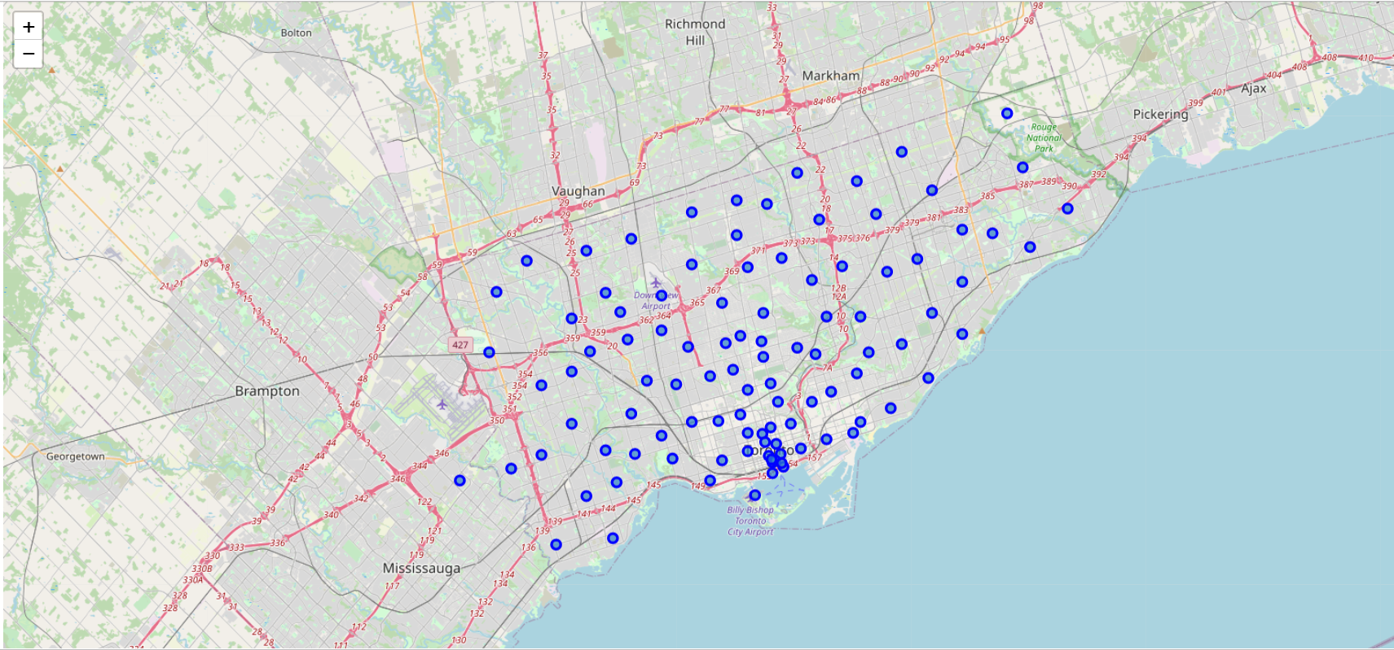

Foursquare was used to leverage a data repository of popular venues specific to the Toronto region and the associated neighborhoods.



A DataFrame was created using the Python Pandas library that first merged the neighborhood data and postal code data with geographical longitudinal and latitudinal data.

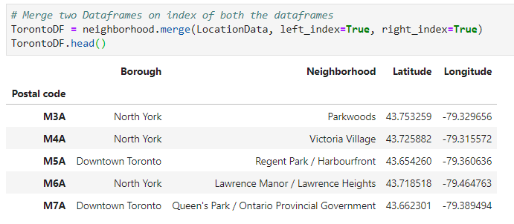

A Python algorithm was further modified to derive up to 100 venues within 500 meters of each of the geographic neighborhood centers queried and create a DataFrame from this.

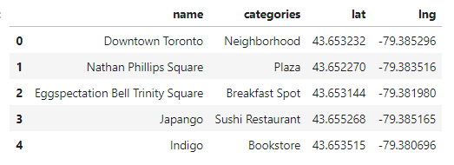

Both independent DataFrames were joined to create a new reference table linking neighborhoods, their geographic location in the Toronto area, and venues of interest and their relative associated geographic locations.

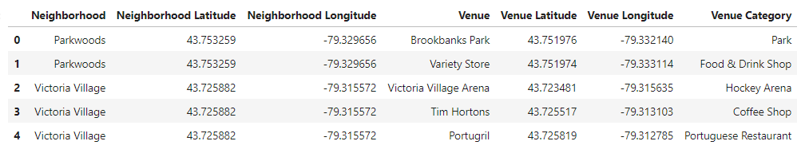

Venues were assessed for popularity and for each neighborhood the associated combination of venue – by popularity – was listed with it creating a sortable table.

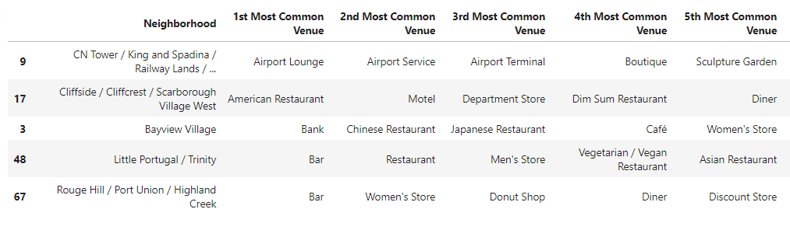

A statistical tool known as K-Means clustering was employed to sort the data of neighborhoods, venues, and relate their relative popularity into a DataFrame. This table was then sorted by utilizing the Python Pandas library into a prioritized and searchable dataset.

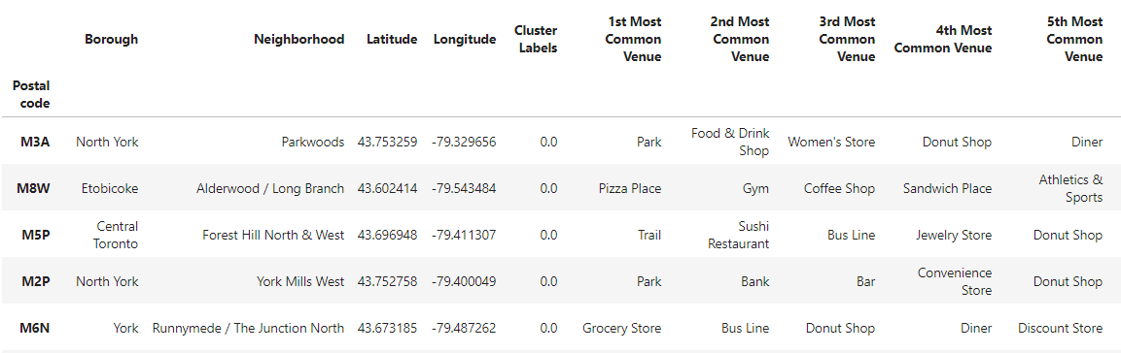

The associated clustered data can be seen on the Toronto map.

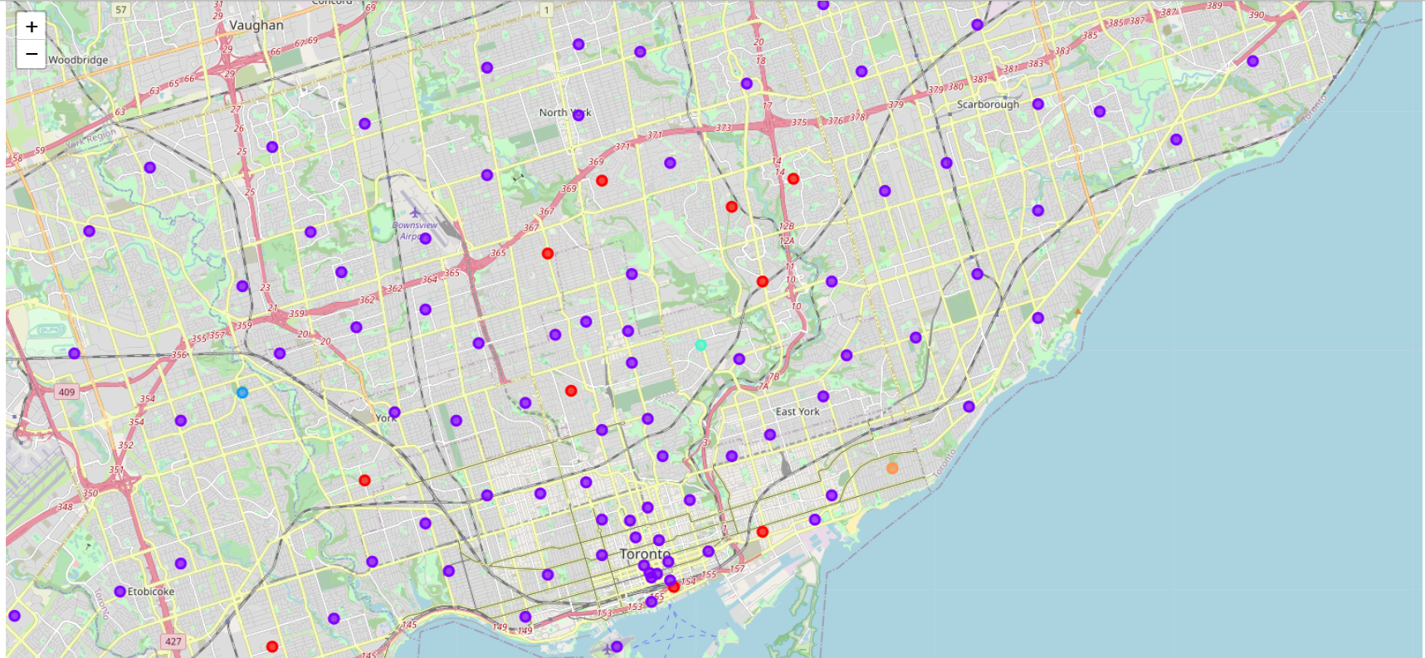

By searching for the list of prioritized amenities and manipulating the K-Means clustering values various iterations of analysis were performed and yielded a decision to consider the cluster located in the circled area in the above figure.

Looking at the specific data analysis results of the cluster locations the specific neighborhood of the Don Mills neighborhood seems most desirable given its resulting amenities and location with respect to other city features.

The Don Mills location as seen with immediate amenities and geographic attractions.

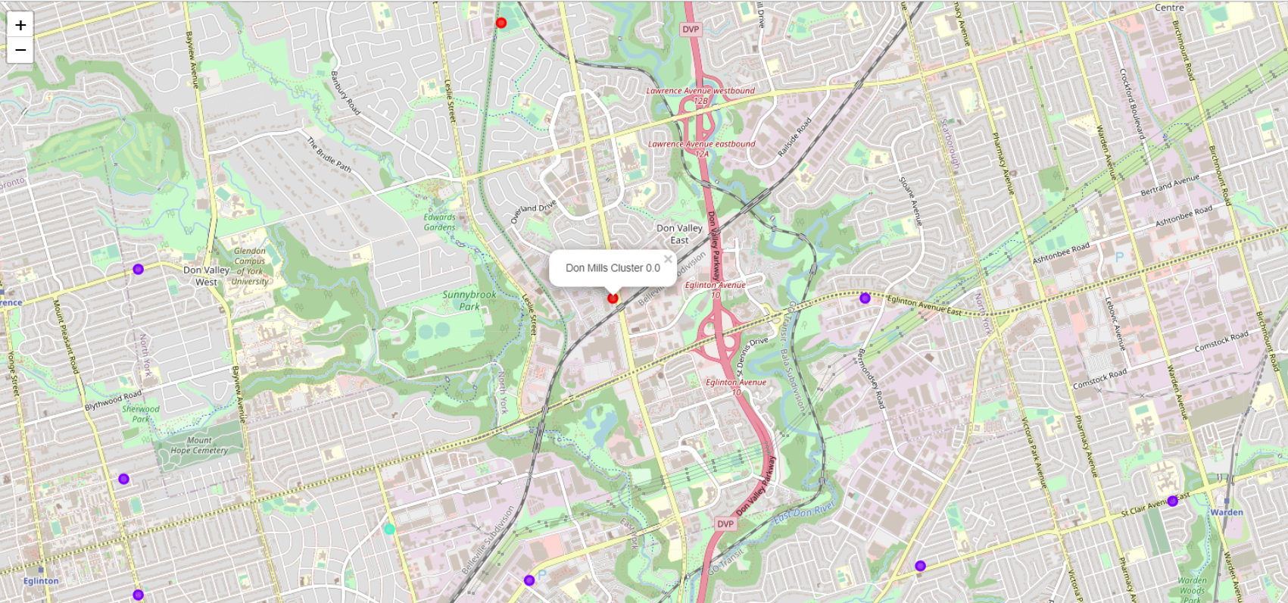

Immediate to the Don Mills neighborhood are: gyms and fitness facilities, a variety of restaurants including Asian and Japanese cuisine, coffee shops, and a concert hall. Also, and of greatest importance – is the abundance of various living accommodations ranging from private homes to apartments and condominiums.

The application of a data science approach to searching and sorting data and transforming it into consumable and objective information for the purposes of decision making have proved invaluable.